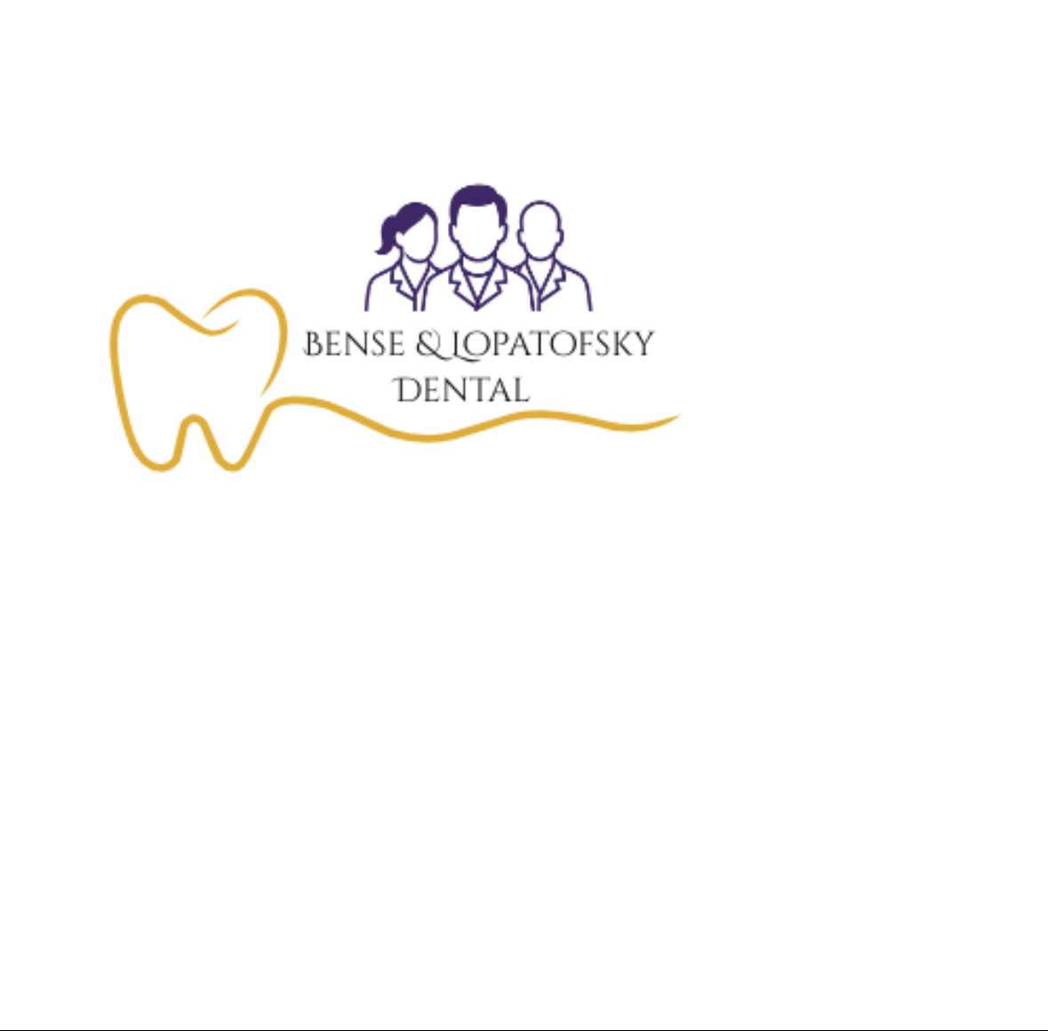

1100 West Main St
Troy, PA 16947
570-297-2113

